Assignment 10: 14, 15

Use Dijkstra’s algorithm to find the shortest path from *a* to *z* for each of the graphs in 13–16. In each case make tables similar to Table 10.7.1 to show the action of the algorithm.

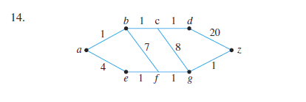

|  |  |  |  |  |  |  |  |  |  |  |  |
| --- | --- | --- | --- | --- | --- | --- | --- | --- | --- | --- | --- |
| Step | V(T) | E(T) | F | L(a) | L(b) | L(c) | L(d) | L(e) | L(f) | L(g) | L(z) |
| 0 | {a} | Ø | {a} | **0** | ∞ | ∞ | ∞ | ∞ | ∞ | ∞ | ∞ |
| 1 | {a} | Ø | {b,e} | 0 | **1** | ∞ | ∞ | 4 | ∞ | ∞ | ∞ |
| 2 | {a,b} | {{a,b}} | {c,f,e} | 0 | 1 | 2 | ∞ | 4 | 8 | ∞ | ∞ |
| 3 | {a,b,c} | {{a,b},{b,c}} | {e,d,g} | 0 | 1 | 2 | 3 | 4 | 8 | 10 | ∞ |
| 4 | {a,b,c,d} | {{a,b},{b,c},{c,d}} | {e,z} | 0 | 1 | 2 | 3 | **4** | 8 | 10 | 23 |
| 5 | {a,e} | {{a,b},{b,c},{c,d},{a,e}} | {f} | 0 | 1 | 2 | 3 | 4 | **5** | ∞ | ∞ |
| 6 | {a,e,f} | {{a,b},{b,c},{c,d},{a,e},{e,f}} | {g} | 0 | 1 | 2 | 3 | 4 | 5 | **6** | ∞ |
| 7 | {a,e,f,g} | {{a,b},{b,c},{c,d},{a,e},{e,f},{f,g}} | {z} | 0 | 1 | 2 | 3 | 4 | 5 | 6 | **7** |
| 8 | {a,e,f,g,z} | {{a,b},{b,c},{c,d},{a,e},{e,f},{f,g},{g,z}} |  |  |  |  |  |  |  |  |  |

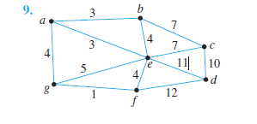

15. The graph of exercise 9 with *a* = *a* and *z* = *f*

|  |  |  |  |  |  |  |  |  |  |  |
| --- | --- | --- | --- | --- | --- | --- | --- | --- | --- | --- |
| Step | V(T) | E(T) | F | L(a) | L(b) | L(c) | L(d) | L(e) | L(g) | L(z) |
| 0 | {a} | Ø | {a} | **0** | ∞ | ∞ | ∞ | ∞ | ∞ | ∞ |
| 1 | {a} | Ø | {b,e,g} | 0 | **3** | ∞ | ∞ | 3 | 4 | ∞ |
| 2 | {a,b,e} | {{a,b},{a,e}} | {g,c,f} | 0 | 3 | 10 | ∞ | 3 | 4 | 7 |
| 3 | {a,g} | {{a,b},{a,e},{a,g}} | {f} | 0 | 3 | 10 | ∞ | 3 | 4 | **5** |
| 4 | {a,g,f} | {{a,b},{a,e},{a,g},{g,f}} |  |  |  |  |  |  |  |  |